IMAGE RECOGNITION
PHASE-5

- INTRODUCTION
  - Project overview
- OBJECTIVE
- DEVELOPMENT
  - Problem Definition and Design Thinking
  - Innovation-Transforming Design into Solutions
  - Create an IBM cloud account
- SYSTEM ARCHITECTURE
- PROPOSED METHODOLOGY
- REQUIRMENT SPECIFICATION
- IMPLEMENTATION
- SCREENSHORTS
10.CONCLUSION
11 FUTURESCOPE

INTRODUCTION
  - PROJECT OVEVIEW

Image Recognition is a tool that using cloud visual recognition algorithms to analyze images and allow users to automatically identify subjects and objects contained within the image and organize and classify these images into categories.The purpose of an image recognition system is to analyze and identify objects, patterns, or features within images. It has various applications, including: Identifying and categorizing objects within images, such as detecting animals in wildlife photos. Recognizing and verifying individuals based on facial features, often used for security and access control.Converting printed or handwritten text in images into machine-readable text. Assisting in the diagnosis of medical conditions by analyzing medical images like X-rays or MRIs.Enabling self-driving cars to detect and respond to objects and road signs.Enhancing real-world experiences by overlaying digital information on images or videos.Checking for defects or inconsistencies in manufacturing processes through image analysis. Filtering out inappropriate or harmful content in user-generated images and videos on platforms.Monitoring crop health, detecting diseases, and optimizing farming practices using aerial imagesTransforming images into art styles, applying filters, or enhancing special effects in movies and games.Image recognition systems use machine learning and deep learning techniques to achieve these purposes, making them valuable in a wide range of industries.The IBM Visual Insights platform, built on cognitive infrastructure,is a new generation of video/image analysis platforms. The platform offers built-in deep learning models that learn to analyze images and video streams for classification and object detection.IBM Cloud Visual Recognition includes tools and interfaces for anyone with limited skills in deep learning technologies. You can use IBM Cloud Visual Recognition to easily label images and videos that can be used to train and validate a model. The model can then be validated and deployed in customized solutions that demand image classification and object detection.

OBJETIVE

It identifies objects or scenes in images and uses that information to make decisions as part of a larger system. Image recognition is helping these systems become more aware, essentially enabling better decisions by providing insight to the system.The IBM Visual Insights platform, built on cognitive infrastructure,is a new generation of video/image analysis platforms. The platform offers built-in deep learning models that learn to analyze images and video streams for classification and object detection.IBM Cloud Visual Recognition includes tools and interfaces for anyone with limited skills in deep learning technologies.

DEVELOPMENT

3.1 PROBLEM DEFINITION AND THINKING DESIGN
Problem Definition:
The project involves creating an image recognition system using IBM Cloud Visual Recognition. The goal is to develop a platform where users can upload images, and the system accurately classifies and describes the image contents. This will enable users to craft engaging visual stories with the help of AI-generated captions, enhancing their connection with the audience through captivating visuals and compelling narratives.

Thinking Design
1) Image Recognition Setup:
- Set up the IBM Cloud Visual Recognition service and obtain the necessary API keys.
2) User Interface:
- Design a user-friendly interface for users to upload images and view the AI-generated captions.
3) Image Classification:
- Implement the image classification process using the IBM Cloud Visual Recognition API.
4) AI-Generated Captions:
- Integrate natural language generation to create captions for the recognized images.
5) User Engagement:
- Design features to allow users to explore, save, and share their AIenhanced images

3.2 INNOVATION-TRANSFORMING DESIGN INTO SOLUTION
Step 1: Design Refinement
Review and refine the initial design concept based on feedback and additional research.

Step 2: Technology Selection
Choose appropriate technologies and tools to implement the design.

Step 3: Data Collection and Preparation
Gather necessary data and preprocess it for analysis and model training.

Step 4: Sentiment Analysis Integration
Explain how sentiment analysis will be incorporated into our solution.

Step 5: Solution Development
Describe the development process, including coding, testing, and iterations.
Step 6: User Interface Design
Create an intuitive and user-friendly interface for our solution.
Step 7: Testing and Validation
Detail the testing methods and validation criteria.
Step 8: Deployment
Plan for deploying the solution and making it accessible to users.
Step 9: Monitoring and Maintenance
Outline strategies for ongoing monitoring, maintenance, and updates.

3.3 Create an IBM Cloud Account
Step 1: Create an IBM Cloud Account
Use the link given to signup or login to IBM cloud. https://cloud.ibm.com/registration
If you already have an IBM Cloud account you can just log in using the link above the Email field.
Step 2: Confirm Your Email Address
An email is sent to your email address to confirm your account. Go to your email account, and click on the “Confirm Account” link in the email that was sent to you.
Step 3: Login to Your Account
Step 4: Create a New Resource
On your dashboard page, click on the Create a resource on the top right to create a new source.
Step 5: Create a Visual Recognition and Watson Studio Resource
On the Catalog page, select the AI category from the left pane, and then select the Visual Recognition resource.On the Catalog page, select the AI category from the left pane, and then select the Watson Studio resource. On the next page, you will get to name your service instance and choose your region. Click on the arrow to reveal the drop-down menu of regions. Make sure to select the region that is closest to you. Then scroll down and make sure that the lite plan is selected, and click the Create button.On the next page, click the Get Started button to start using Watson Studio.

Step 6: Create a Project
Once you land on the IBM Watson Studio main page, start by creating a project.

Step 7: Set up Your Project

Fill in some project details and click Create. The IBM Cloud Object Storage, which provides you storage for your images, should be automatically created for you but if not created you can click on add button below the heading on top right part of screen. if it is already created it will show you name and will not let you create a new one and create the storage service with the lite plan and click on create button. Go to Add to project and choose Image classification.

Step 8: Selecting Built-in Models for Watson Visual Recognition

After creating your project, by default, you will land on the page where you can perform some advanced tasks but we will skip this for now and use the built-in models. To access the built-in models, click on the name of the service, as seen in the red box.

Step 9: Choose the General model.

Now you can see all the built-in image classification models that IBM Watson provides! Let’s try the General model.

Step 10: Try out the General model

To test the General model, click on Test tab on top of screen.

Step 11: Upload Your Images!

Now you can upload any images you’d like by clicking on Browse. Remember that you will have to upload all the images that you want to test in a single go as once you upload images then you cannot add more images one by one. you will have to go back and upload all images including the new ones.

Step 12: Check Out the Results!

Once you have uploaded your images, it will tell you what it found in your images! Beside each class of object (or color, age, etc.), it will also give you a confidence score (between 0 and 1) on how confident it thinks it found that particular object in your image (0 for lowest confidence and 1 for highest confidence).

Step 13: Filter Your Results

You can even filter your results based on tag generated from images by selecting the tags from list in left hand side of screen.

SYSTEM ARCHITECTURE

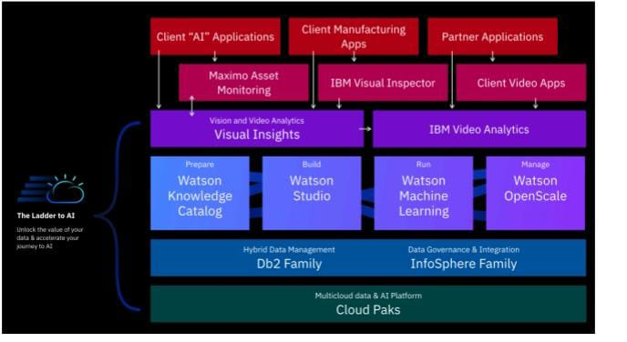

PROPOSED METHODOLOGY

It is intended that the design of this investigation be divided into four major stages, which are as follows
- Data preprocessing and preparation
- Possibility of feature extraction
- Developing and extracting views and information
- Classification of points of view
The data that are obtained from the web content are not appropriately formatted at the time of extraction. The first step prepares the data in preparation for the sentiment analysis and extraction to take place later on. Users' opinions in product evaluations are mined for product attributes using opinion mining as one possible method of discovering and matching up to the power and scarcity of things.

REQUIRMENT SPECIFICATION

the software and hardware requirements and understand the supported file types before you can install IBM Cloud .
Hardware requirements IBM Visual Insights requires the following hardware:
Hardware
The following dSSevices are supported:
• POWER8 S822LC (8335-GTB) or POWER9 AC922 with at least one NVIDIA NVLink capable GPU
• POWER9 IC922 with at least one NVIDIA T4 GPU
• x86 system with at least one NVIDIA Pascal, Volta, or Turing-architecture GPU
Required specifications
Your device must meet these minimum requirements:
• 64 GB of memory
• Ethernet network interface
• 75 GB of storage for installation, and at least 40 GB of storage for runtime. See “Disk space requirements” on page 18 for details.
• The Nvidia GPU must be configured in the "Default" compute mode. The "Exclusive Process" mode will cause trainings to fail. See nvidia-smi usage for details on compute modes.
• There are multiple options for deploying the model for testing.
Software requirements
You must install the following software before you install IBM Visual Insights:
Linux
• Red Hat Enterprise Linux (RHEL) RHEL 7.6 ALT (little endian) for POWER9™
• RHEL 7.7 for x86
• Ubuntu 18.04
Image support
• The following image formats are supported:
– JPEG
– PNG
– DICOM
• Images with COCO annotations are supported. For details, see “Importing
images with COCO annotations”.

IMPLEMENTATION

INPUT;

from ibm_watson import VisualRecognitionV4
from ibm_watson.visual_recognition_v4 import FileWithMetadata, AnalyzeEnums

# Initialize the Visual Recognition service
visual_recognition = VisualRecognitionV4(
version='2021-09-09',
authenticator_id='apikey',
authenticator_type='iam',
authenticator_implicit=False,
authenticator_url='YOUR_API_URL',
authenticator_apikey='YOUR_API_KEY'
)

# Analyze an image
with open('path_to_your_image.jpg', 'rb') as image_file:
results = visual_recognition.analyze(
images_file=FileWithMetadata(image_file),
features=[AnalyzeEnums.Features.OBJECTS.value],
).get_result()

# Print the results
print(results)

OUTPUT;

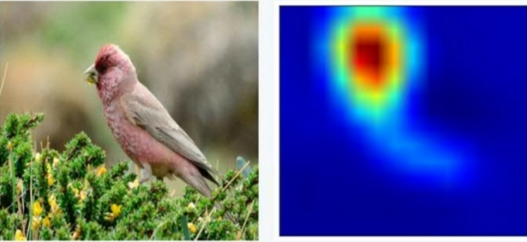

Fig.1 Detecting the overall contents of the image, based on the custom training data.

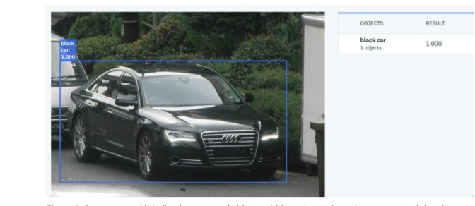

Fig.2 Detecting and labelling instance of objects within an image, based on the custom training data.

.

SCREENSHORTS

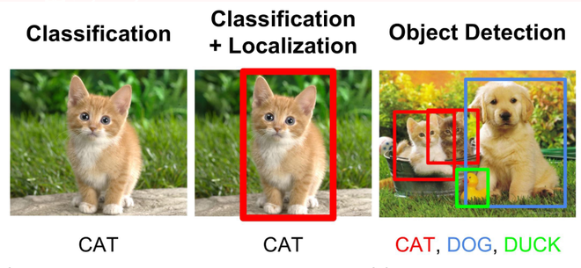

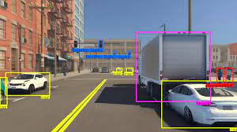

OBJECT DETECTION

CONCLUSION

Imag Image recognition systems offer a range of
benefits, includinautomation, efficiency, accessibility, and
applications in various fields like healthcare and security.
However, they also come with challenges related to data
privacy, bias, accuracy, and ethical concerns. To ensure
responsible use, these issues need to be addressed.

FUTURESCOPE

1. *Improved Accuracy*:
Ongoing research and advancements in machine learning will likely lead to more accurate image recognition systems, reducing the risk of misidentifications.

2. *Bias Mitigation*:
Efforts to reduce bias in image recognition algorithms will continue, leading to more fair and equitable outcomes, particularly in areas like facial recognition.

3. *Real-time Applications*:
Image recognition will find applications in real-time settings, such as autonomous vehicles, where rapid and accurate image analysis is crucial.

4. *AI in Healthcare*:
Image recognition will play a greater role in healthcare, assisting in the diagnosis of various medical conditions and enabling remote patient monitoring.

5. *Retail and E-commerce*:
Enhanced image recognition will enable improved product recommendations and visual search capabilities, enhancing the online shopping experience.

